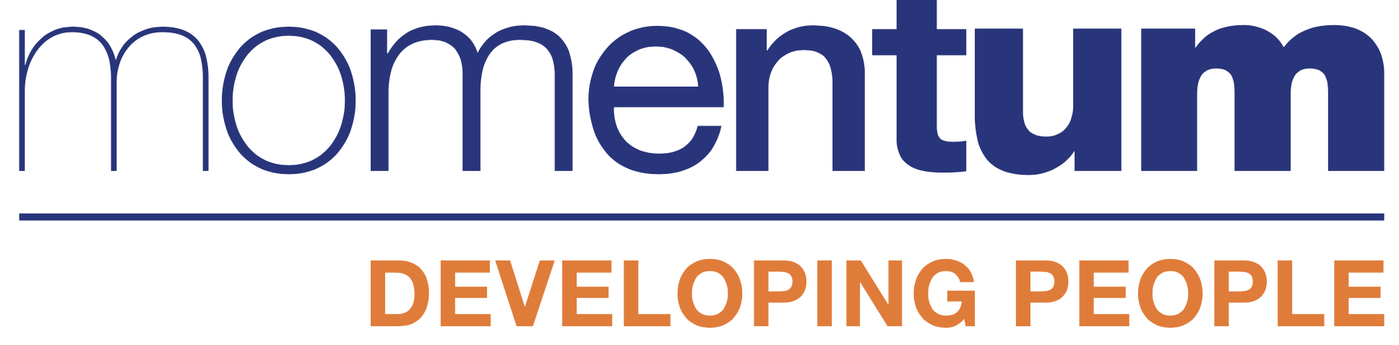

How to be free from the thoughts and feelings that hold you back
18th March at 6.00pm – 7.00pm

Have you ever thought about where your feelings come from? No? I hadn’t! Having a complete breakdown was the catalyst for me to find out. In this talk I will share the most important things I’ve learned over the last 15 years about how to have more freedom from the feelings and thoughts that hold us back.

I’m on a mission to share:
- Where feelings actually come from in comparison to where we think they come from
- How to be free from the impact other people have over how we feel
- How to be ok even when the things around us are not

The ideas I’ll be sharing are now being shared in schools and colleges. The NHS are gathering data to show the impact that these ideas have on mental health and businesses and organisations around the world are teaching these ideas and turning their companies around to create happy, engaged and inspired employees.
Sounds too good to be true?
Come and find out.

Mo (Harford) Bury works in large organisations, coaching, training and speaking at events to share an understanding and show how we can change how we experience everything - life, work, our customers and each other.
There’s nothing you have to be, have or do to feel happy, whole and at ease when you know how your mind is creating your experience.

For more information about Mo please take a look at over 100 recommendations on LinkedIn linkedin.com/in/mobury
or look at her web site https://www.momentumtraining.biz/

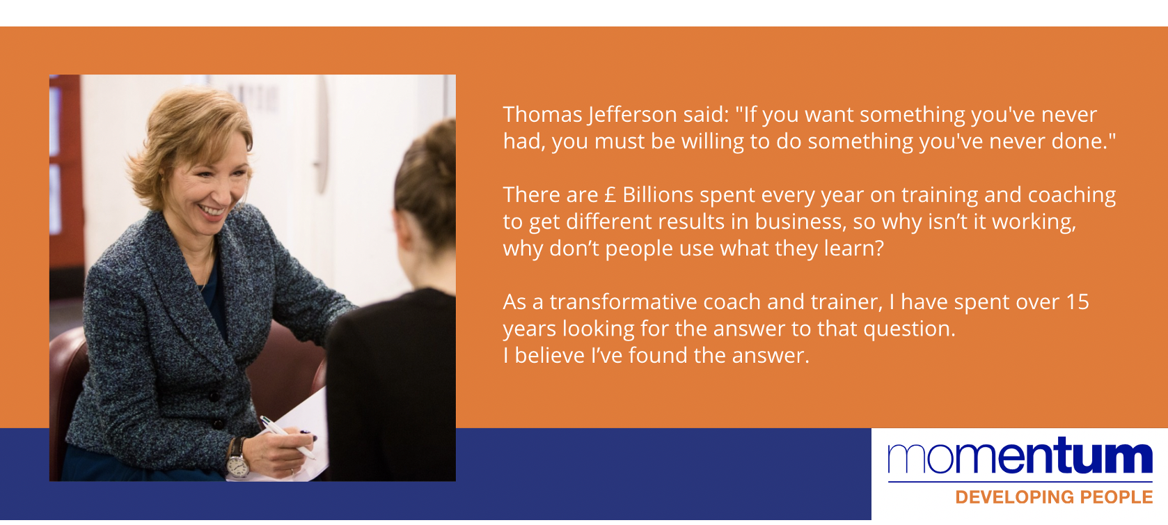

Mo (Harford) Bury
Brain-friendly people development.
Better Thinking = Better Business

t: +44 (0) 844 251 0529
m: +44 (0) 7792903668
e: mo.bury@momentumtraining.biz
l: linkedin.com/in/mobury

